DATA ANALYSIS AND VISUALIZATION
INT387

PROJECT REPORT
(Project Semester January – April 2026)

Suicide Patterns in India: A Data-Driven Analysis
Using Power BI Dashboard Visualizations (2018–2022)

Submitted by
Vansh Rana
Registration No.: 12408787
Roll No.: 44
Programme and Section: BTech CSE – 424GB
Course Code: INT387

Under the Guidance of
Savleen Kaur

Discipline of CSE/IT
Lovely School of Computer Science Engineering
Lovely Professional University, Phagwara

CERTIFICATE
This is to certify that Vansh Rana bearing Registration no. 12408787 has completed INT387 project titled,
"Suicide Patterns in India: A Data-Driven Analysis Using Power BI Dashboard Visualizations (2018–2022)"
under my guidance and supervision. To the best of my knowledge, the present work is the result of his/her original development, effort and study.

Signature and Name of the Supervisor
Designation of the Supervisor
School of Computer Science Engineering
Lovely Professional University
Phagwara, Punjab.

Date:

DECLARATION
I, Vansh Rana, student of BTech under CSE/IT Discipline at Lovely Professional University, Punjab, hereby declare that all the information furnished in this project report is based on my own intensive work and is genuine.

Date: Signature

Registration No.: 12408787
Name of the Student: Vansh Rana

Acknowledgement
I would like to express my sincere gratitude to my faculty coordinator for providing continuous guidance and support throughout this project. I am thankful to the National Crime Records Bureau (NCRB), Government of India, for making comprehensive suicide statistics publicly available through their annual Accidental Deaths & Suicides in India (ADSI) report, which served as the primary data source for this analysis.

I also wish to acknowledge the tools and technologies — Microsoft Excel and Microsoft Power BI — that enabled the data preprocessing, visualization, and analytical work presented in this report.

Finally, I thank my peers and family for their encouragement and support during the course of this project.

Vansh Rana
Registration No.: 12408787

Table of Contents
Acknowledgement 1
Table of Contents 1
1. Introduction 1
2. Source of Dataset 1
2.1 Primary Data Source 1
2.2 Dataset Coverage 1
3. Dataset Preprocessing 1
3.1 Data Cleaning Steps 1
Step 1: Null Value Removal 1
Step 2: Standardization of Column Names 1
Step 3: Data Integration 1
Step 4: Data Type Validation 1
3.2 DAX Measures Created in Power BI 1
3.3 Final Dataset Summary 1
4. Analysis on Dataset 1
4.1 Dashboard 1: Executive Overview 1
i. General Description 1
ii. Specific Requirements 1
iii. Analysis Results 1
iv. Visualization 1
4.2 Dashboard 2: State & Geographic Analysis 1
i. General Description 1
ii. Specific Requirements 1
iii. Analysis Results 1
iv. Visualization 1
4.3 Dashboard 3: Cause Analysis 1
i. General Description 1
ii. Specific Requirements 1
iii. Analysis Results 1
iv. Visualization 1
4.4 Dashboard 4: Year-on-Year Trend & Growth 1
i. General Description 1
ii. Specific Requirements 1
iii. Analysis Results 1
iv. Visualization 1
5. Conclusion 1
1. A Consistent and Alarming Upward Trend 1
2. Severe and Persistent Gender Disparity 1
3. Geographic Concentration in a Few States 1
4. Family Problems as the Leading Cause 1
5. Socioeconomic Vulnerability 1
6. Future Scope 1
7. References 1

1. Introduction
In India, suicide is an urgent public health issue. On average, over thousands of people lose their lives to suicide every year. They are a tragic loss for family and friends; they also impose an economic burden on society. To create successful intervention efforts and develop data-driven policies, it is important to understand how suicides occur in terms of patterns, reasons, and demographics.

This initiative conducts a data-based assessment of suicides within India over the five-year period (2018-2022), collecting data from the National Crime Records Bureau (NCRB) statistics on suicide incidents throughout the country. The research will address how suicides are divided into various segments, including:
• Gender;
• Geographic location (both at the state and union territory levels);
• Reasons for suicide;
• Socioeconomic factors (economic status, level of education, marital status, occupation);
• Year-to-year patterns and variations.

All of the data will be presented through Power BI. Four interactive dashboards have been created to provide the user with clear and detailed statistics, insights, and data to understand suicides in India. The dashboards include:
- A high-level overview of suicides (national) across India
- A geographic/state-level analysis that identifies suicide "hot spots" in India
- A detailed cause analysis of suicides providing a description of the leading causes of death by suicide
- A year-on-year trend and growth analysis tracking changes over five years.

The outcomes of this endeavour can be especially useful to policymakers, mental health practitioners, investigators, and social service representatives involved in mitigating suicide rates within India.

2. Source of Dataset
This study relied upon statistical data collected through the National Crime Records Bureau's (NCRB), Government of India annual publication called “Accidental Deaths & Suicides in India (ADSI).” The ADSI contains aggregated mode of circumstances leading to suicide in the country grouped by cause, socio-economic conditions of individuals (e.g., economical, education level, single/divorced/married, occupation), and various other criteria throughout India

2.1 Primary Data Source
The NCRB collects and compiles detailed data regarding suicide from all 36 Indian states and Union Territories. This information can be accessed via the NCRB's website, www.ncrb.nic.in, within their “Crime in India” section and the ADSI report series. For this study, five different source files were used:

Source File | Category | Description
suicides-by-causes.xlsx | Cause | 30 subcategories of causes (Family Problems, Illness, Drug Abuse, etc.)
suicides-by-economic-status.xlsx | Economic | 4 income brackets (Below ₹1L to ₹10L and above)
suicides-by-educational-status.xlsx | Education | 9 education levels (No Education to Graduate and above)
suicides-by-marital-status.xlsx | Marital | 7 marital status categories
suicides-by-profession-wise.xlsx | Profession | 31 occupational categories

2.2 Dataset Coverage
- Time Period: 2018 – 2022 (5 years)
- Geographic Coverage: 36 States and Union Territories of India
- Gender Categories: Male, Female, Transgender
- Total Records in Unified Dataset: 18,306 rows
- Total Suicide Incidents Recorded: 4,287,493 (aggregated across all categories)

3. Dataset Preprocessing
For this study, data collected from NCRB was segregated in different Excel files for each data type. Upon acquiring all necessary data, a number of procedures were conducted on it to clean, reform, and combine it into one formatted and organized dataset appropriate for analysis.

3.1 Data Cleaning Steps

Step 1: Null Value Removal
Rows that contained null values (missing data) in any column were identified and removed when applicable from their respective source files. This ensured that no incomplete records were included in the analysis, maintaining data integrity and preventing calculation errors in Power BI measures.

Step 2: Standardization of Column Names
A uniform set of column names across the five original files were created. The resulting combination includes four columns, which will consist of Year, Value, State, and Gender.
Column Name | Data Type | Description
Year | Year | Year of the suicide record (2018–2022)
State | Text | Full name of the State or Union Territory
State Code | Integer | Numeric code assigned to each State/UT
Gender | Text | Gender of the individual (Male / Female / Transgender)
Category | Text | Broad category (Cause / Economic / Education / Marital / Profession)
Subcategory | Text | Specific subcategory within the broader category
Value | Integer | Number of suicides recorded for that row

Step 3: Data Integration
All five cleaned-up source files will need to be combined into a single master file by merging ("Power Query Merge") using Microsoft Power BI.

Step 4: Data Type Validation
The fourth step involves verifying that all five files have the same data type for each of their four fields: "Year/Value" fields will be "integer," and "State/Gender/Category/Subcategory" fields will be "text." The "StateCode" field must be "integer" in order to facilitate the creation of map visualizations in Power BI. Any subcategories that had non-standardized values were also replaced for improved visualization.

3.2 DAX Measures Created in Power BI
The following custom DAX (Data Analysis Expressions) measures were created in Power BI to support the dashboard visualizations:

Measure Name | DAX Formula | Purpose
Total_Suicides | SUM('Table'[Value]) | Total suicide count across all filters
Male_Suicides | CALCULATE(SUM('Table'[Value]), 'Table'[Gender] = "Male") | Total male suicide count
Female_Suicides | CALCULATE(SUM('Table'[Value]), 'Table'[Gender] = "Female") | Total female suicide count
Male_Percentage | DIVIDE([Male_Suicides], [Total_Suicides]) * 100 | Percentage of suicides that are male
Growth_Rate | DIVIDE(CurrentYearValue - PreviousYearValue, PreviousYearValue) | Year-on-year percentage change

3.3 Final Dataset Summary

Parameter | Value
Total Rows | 18,306
Years Covered | 2018, 2019, 2020, 2021, 2022
States / UTs | 36
Gender Categories | Male, Female, Transgender
Broad Categories | 5 (Cause, Economic, Education, Marital, Profession)
Total Subcategories | 81
Total Suicides (Sum of Value) | 4,287,493

4. Analysis on Dataset

4.1 Dashboard 1: Executive Overview

i. General Description
The Dashboard is the initial main page of the Power BI application. It contains national-level data (2018–2022) for overall Suicide rates, by year, gender and category. Users can use the two slicers (year and gender) to filter all of the dashboard visualizations simultaneously and quickly for either time periods and/or demographic groups.

ii. Specific Requirements
- KPI Cards displaying Total_Suicides, Male_Suicides, and Female_Suicides as large-format headline numbers.
- Year Slicer (single-select radio button style) and Gender Slicer for interactive filtering.
- Line Chart with dual Y-axes: Total_Suicides (primary) and Growth_Rate (secondary) by Year.
- Donut Chart showing gender-wise distribution of suicides (Male, Female, Transgender).
- Horizontal Bar Chart showing Total_Suicides by Category (sorted descending).
- Clustered Bar Chart (Male_Suicides vs Female_Suicides by Year).

iii. Analysis Results
The dashboard reveals the following key national-level insights:

Metric | Value | Interpretation
Total Suicides (2018–2022) | 4,287,493 | Cumulative across all categories and genders
Male Suicides | 3,090,536 | 72.08% of all suicides
Female Suicides | 1,196,382 | 27.90% of all suicides
Transgender Suicides | 575 | 0.01% — a severely underreported segment
2018 Count | 755,561 | Baseline year
2022 Count | 961,623 | 27.3% higher than 2018 baseline
Peak Growth Year | 2019–2020 | 10.20% single-year increase

Professions are accountable for a higher overall count than any other single category (1,064,172). The Cause category follows with 938,377 and the remaining three categories (Economic, Education, and Marital) are almost equal at about 761,648 each due to the manner the data set has been structured; thus, each person is represented once per dimension of category. The steady, upward trend from 2018 to 2022 shows that the national suicide rate is increasing at an alarming rate and will require immediate policy intervention.

The gender gap in suicide is significant; every year of the study shows that over 72% of all people who die by suicide are male. This is in alignment with global trends in that men have a higher incidence of suicide than women, largely because of differences in method of suicide and help-seeking behaviours.

iv. Visualization
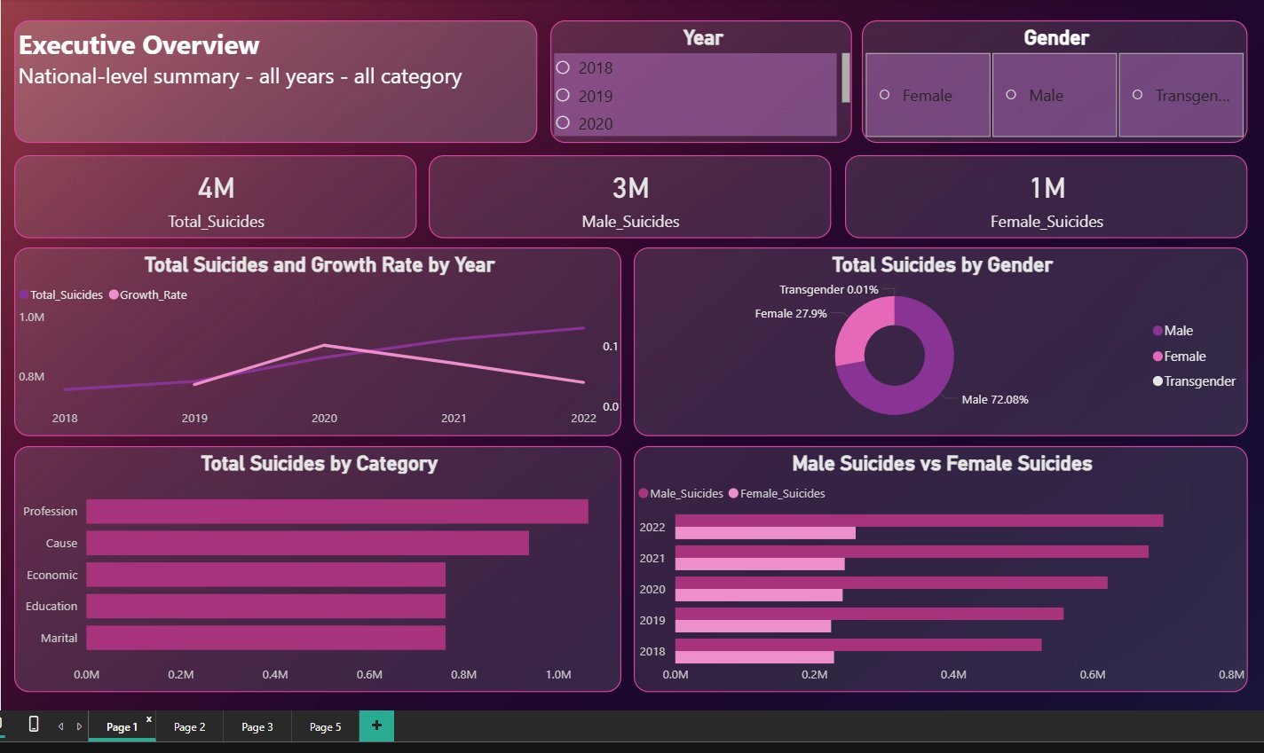
Figure 1: Executive Overview Dashboard — National-level KPIs, gender donut, category bar, and gender trend (2018–2022)

4.2 Dashboard 2: State & Geographic Analysis

i. General Description

The State and Geographic Analysis dashboard provides information regarding the geographic location of suicides throughout India's 36 states/Union Territories and assists in the identification of geographic suicide hotspots; comparing state-level trends; providing geographic visualizations of suicide occurrence. The filled map in country provides a quick visual assessment of geographic distribution of burden for suicide, and assist to provide an easily referenceable bar chart showing the top 10 states and a detailed matrix table.

ii. Specific Requirements
- Filled Map of India: Color intensity proportional to Total_Suicides per state. Darker shading indicates higher burden.
- Horizontal Bar Chart: Top 10 states ranked by Total_Suicides (2018–2022 cumulative).
- Matrix Table: State vs Year (2018–2022) with Total_Suicides values and row/column totals.
- Year Dropdown Slicer and State/UT List Slicer for interactive filtering.

iii. Analysis Results
Rank | State | Total Suicides (2018–2022) | % of Top 10 Total
1 | Maharashtra | 594,310 | 17.96%
2 | Tamil Nadu | 468,487 | 14.16%
3 | Madhya Pradesh | 386,160 | 11.67%
4 | Karnataka | 370,942 | 11.21%
5 | West Bengal | 350,147 | 10.58%
6 | Kerala | 250,525 | 7.57%
7 | Telangana | 243,515 | 7.36%
8 | Gujarat | 229,898 | 6.95%
9 | Chhattisgarh | 207,463 | 6.27%
10 | Andhra Pradesh | 206,860 | 6.25%

Over five years, Maharashtra accounts for the highest cumulative number of suicide cases (594,310), contributing to almost 18% of the total suicide cases for the top 10 states. The top five states (Maharashtra, Tamil Nadu, Madhya Pradesh, Karnataka, West Bengal) together account for approximately 65% of the combined burden of the top 10 states.

The table showing the number of suicides in India by year indicates that every major state has demonstrated a steady increase between 2018 and 2022. For example, Maharashtra has shown a growth of 26.2% from 104,934 in 2018 to 132,413 in 2022; Tamil Nadu experienced a growth rate of 46.6% from 77,368 in 2018 to 113,415 in 2022; and Andhra Pradesh experienced significant growth of 65% from 30,697 to 50,655 over the same time period.

Northeast and smaller union territories (such as Andaman & Nicobar Islands and Lakshadweep as well as Dadra & Nagar Haveli) show much lower absolute numbers, but due to the smaller size of their populations, they do not necessarily reflect lower per capita risk.

iv. Visualization
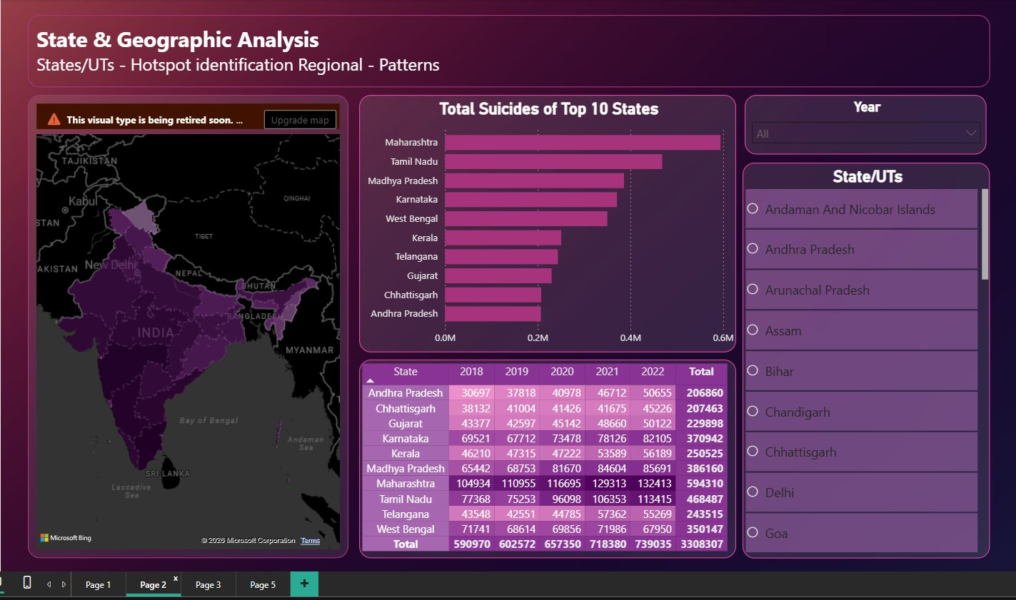
Figure 2: State & Geographic Analysis Dashboard — India map, top-10 states bar chart, and state×year matrix table

4.3 Dashboard 3: Cause Analysis

i. General Description

The Cause Analysis dashboard provides detailed insight into the reasons behind suicide in India. This dashboard is arranged in categories of "Cause," and there are 30 different types of "Categories" across which suicides can be categorized. The dashboard also provides insight into the causes of suicide based on trends over time and distinguishes between men and women. The dashboard includes a 'Category slicer,' which allows users to adjust their selection to cover the "Cause" category by default, but any other browsing option can also be selected.

ii. Specific Requirements
- Treemap (Suicides by Subcategory): Rectangle size proportional to Total_Cause per subcategory.
- Detail Table: Subcategory vs Male_Suicides, Female_Suicides, Total_Suicides, and Male_Percentage — with conditional formatting.
- Line Chart: Top subcategories by Year (2018–2022) showing trend lines for major causes.
- Pie Chart: Overall subcategory percentage distribution.
- 100% Stacked Bar: Gender breakdown (Male / Female / Transgender) per subcategory.

iii. Analysis Results

Rank | Cause Subcategory | Total | Male | Female | Male %
1 | Family Problems | 246,089 | 168,639 | 77,423 | 68.5%
2 | Illness (Total) | 137,147 | 94,910 | 42,206 | 69.2%
3 | Other Causes | 80,231 | 56,521 | 23,696 | 70.4%
4 | Causes Not Known | 78,750 | 55,250 | 23,493 | 70.2%
5 | Illness (Mental/Insanity) | 63,331 | 44,545 | 18,775 | 70.3%
6 | Illness (Other Prolonged) | 61,581 | 41,206 | 20,358 | 66.9%
7 | Drug Abuse / Alcoholic Addiction | 46,416 | 45,410 | 1,000 | 97.8%
8 | Marriage Related Issues | 39,582 | 18,626 | 20,954 | 47.1%
9 | Love Affairs | 33,602 | 20,249 | 13,348 | 60.3%
10 | Bankruptcy or Indebtedness | 29,486 | 26,929 | 2,556 | 91.3%

Family Problems is the greatest cause of suicide in India with 246,089 suicides occurring due to family problems, representing 40.61% of all causes. Among the two genders, Family Problems have had significant impacts on both genders but are gender biased (68.5%). Illness-related causes collectively represent the second largest driver, with total illness suicides exceeding 137,000 (or 260,000+ including mental and prolonged illness subtypes combined).

The most significant difference in gender among the many forms of suicide for which data is available is the difference between men and women with regards to Drug Abuse/Alcoholic Addiction suicides. The gender of 97.8% of the victims of Drug Abuse/Alcoholic Addiction suicides is male; therefore, Drug Abuse/Alcoholic Addiction suicides have the greatest proportion of male victims out of all categories of suicide. The category of Marriage-Related Issues is the only major category where females outnumber males (47.1% male); thus, the data indicates that married women in India face disproportionately high social and familial pressure.

The line chart demonstrates that Family Problems and Illness (Total) has steadily increased from 2018 through 2022. The rate of Family Problems has increased from approximately 40,000/year in 2018 to almost 60,000/year in 2022, a 50% increase over five years. This trend illustrates the increasing incidence of domestic stress and interpersonal conflict as causes of suicide within the context of the post-COVID social environment.

iv. Visualization
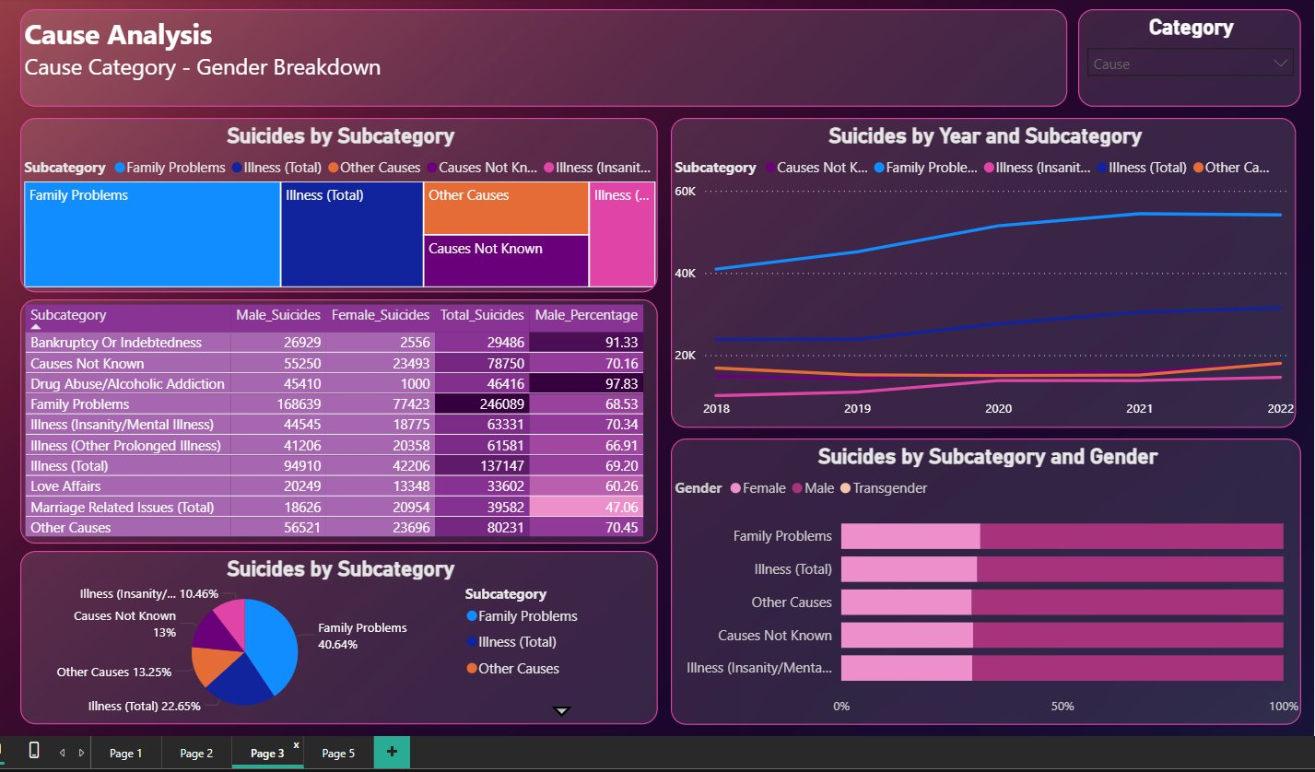
Figure 3: Cause Analysis Dashboard — subcategory treemap, detail table, trend lines by year, and gender breakdown bar chart

4.4 Dashboard 4: Year-on-Year Trend & Growth

i. General Description
The Year-on-Year Trend and Growth report on suicides provides a historical view of pattern changes in India over time, by examining how the number of suicides in total has changed between 2018 and 2022 and showing the progression of suicides state-by-state over this time period, identifying both all-time peaks (i.e., The Year of Most Rapid Growth) and states that experienced the most rapid growth during the analysis period. The Growth_Rate DAX measure serves as the main analytic tool for this portion of the report and is used as a percentage change for each state using the number of suicides in one year compared to the number of suicides in the previous years.

ii. Specific Requirements
- KPI Cards: Total_Suicides (cumulative 4M) and Growth_Rate (average across all years).
- Donut Chart: Distribution of total suicides by Year — showing proportional contribution of each year.
- Small Multiples Line Chart: State-level trajectories for the top 4 states (Karnataka, Madhya Pradesh, Maharashtra, Tamil Nadu).
- Area/Line Chart with Dual Axis: Total_Suicides (area) and Growth_Rate (line) by Year.

iii. Analysis Results

Year | Total Suicides | Year-on-Year Growth | % of 5-Year Total
2018 | 755,561 | Baseline | 17.62%
2019 | 782,837 | +3.61% | 18.26%
2020 | 862,705 | +10.20% | 20.12%
2021 | 924,767 | +7.19% | 21.57%
2022 | 961,623 | +3.99% | 22.43%
5-Year Total | 4,287,493 | +27.3% (2018 to 2022) | 100%

The most notable finding from the trend analysis is a spike in growth in 2019-2020, with a 10.20% increase in the number of suicides, which is double the growth of the prior year and the following year. This acceleration coincides with the timing of the COVID-19 pandemic in India, which caused a widespread loss of income and employment, social isolation, restricted access to mental health care, and an increase in mental distress throughout the country.

The KPI card displays a cumulative Growth Rate value of 3.64 or an average year on year growth rate for the entire study period using the custom DAX Growth_rate measure. This shows that suicide rates in India are not static but are continually increasing.

The small multiples chart shows a similar trend across four of the largest states in India; Karnataka, Madhya Pradesh, Maharashtra, and Tamil Nadu, with a significant increase in the year-on-year growth rate from 2019 - 2021. Tamil Nadu has had the most significant increase of all four and observed the fastest growth, while there is more steady but slower growth in Karnataka. The dual-axis chart supports this observation; as this chart shows, the absolute number of suicides increased each year, and the peak year for growth was 2020 with a slowdown in growth since that time (indicating possible stabilization), although the total number is at all-time highs.

The donut chart indicating the amount of suicides in 2022 constitutes 22.43% of all five-year suicides recorded to date (the highest amount for a single year), compared to 17.62% from 2018; thus, it can be seen through the data that the burden of suicide has been progressively shifting toward more recent years.

iv. Visualization
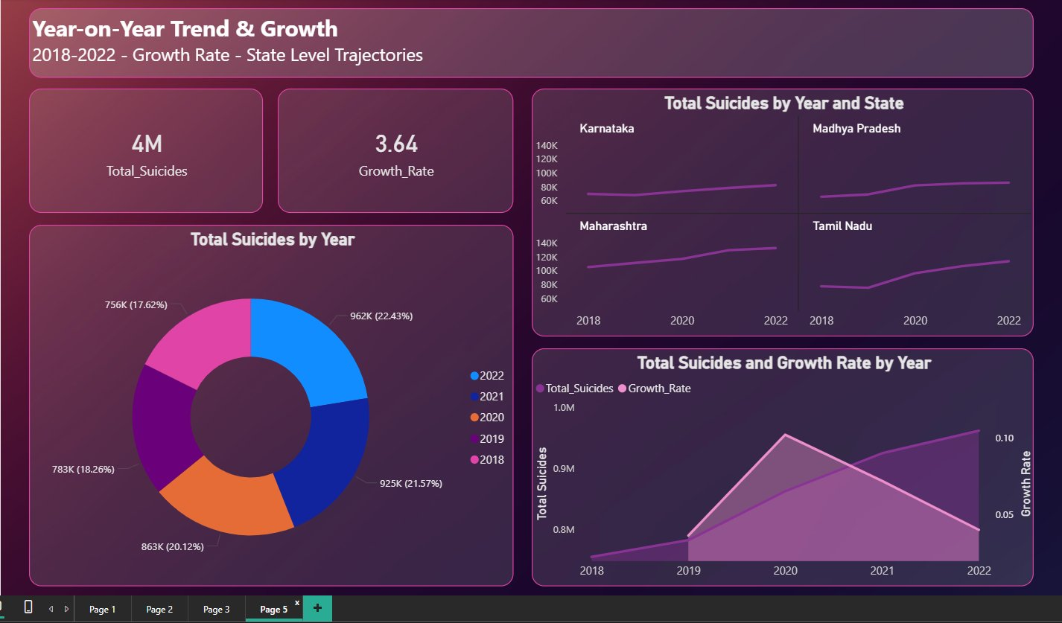
Figure 4: Year-on-Year Trend & Growth Dashboard — KPI cards, donut by year, small multiples by state, and dual-axis trend chart

5. Conclusion
This project has analyzed suicide patterns in India for the five year span from 2018 to 2022, drawing upon official NCRB data that has been integrated and visualized through the use of Microsoft Power BI. Based on that data and subsequent analysis, the project has reported the following findings:

1. A Consistent and Alarming Upward Trend
From 2018 (755,561) to 2022 (961,623), suicide incidents in India have grown by approximately 27.3%. The majority of that growth was seen in the 2019-2020 period, which represented an increase of 10.20%, which coincides with the onset of the COVID-19 pandemic and the associated economic ramifications associated with it; thus, suggesting a need for both policy and action to be developed in a timely manner.

2. Severe and Persistent Gender Disparity
The male population has consistently made up over 72% of the total number of suicides for the study period with particularly high gender disparities for types of suicides such as Drug Abuse / Alcoholic Addiction (male=97.8%) and Bankruptcy or Indebtedness (male=91.3%); which is indicative of the burden of socioeconomic pressures placed upon men. Conversely, Marriage Related Issues is the only major contributor to the total number of suicides where there is near parity, if not exceeding, the number of female suicides compared to male suicides for that category; thus, suggesting that married women are subjected to distinct vulnerabilities compared to their male spouse.

3. Geographic Concentration in a Few States
The total suicide burden experienced within the previous five years (2018-2022) has been exacerbated by a more significant percentage (i.e. >50%) of the total sum of suicides being contributed by five states - Maharashtra, Tamil Nadu, Madhya Pradesh, Karnataka, and West Bengal. Maharashtra alone recorded over 594,000 suicides across the five-year period. These states require targeted, state-specific mental health intervention programs and crisis support infrastructure.

4. Family Problems as the Leading Cause
The leading cause of suicide is family issues, which accounted for 40.6% (246,089) of all suicide cases in the data set. This suggests that there is a need for family counseling services, domestic assistance programs, and mental health support hotlines. In total, the second leading cause of suicide was illness (specifically: mental illness, extended illness, cancer, and paralysis). The intersection of physical and mental health is apparent through the fact that the leading cause of suicide is family problems.

5. Socioeconomic Vulnerability
The economic findings show that individuals who earn less than ₹1 Lakh annually make up 64.7% of all economically categorized suicides. Daily wage workers are most affected, comprising 187,554 or approximately 75% of total annual suicides originating from this profession. Individuals with lower levels of education (primary, middle, or matriculated) represent the majority of all educationally categorized cases of suicide; collectively, their numbers exceed 446,000 in the data set. These results demonstrate the strong correlation between an individual's economic precarity and lack of quality education to their increased risk for committing suicide.

In conclusion, the project has illustrated how the use of data visualization and analytical tools can be used to convert complicated public health data into actionable findings. The dashboards created using Power BI provide a scalable and interactive way to produce annual updates of new data from the National Crime Records Bureau (NCRB) and thus enable continued monitoring and data-driven decisions.

6. Future Scope
This research forms a solid base for further analysis. Future research directions that will extend or build upon the current findings are as follows:

- Incorporate per capita (normalized per state population using census data) suicide statistics so that comparisons between states of various sizes are fair, and the true per capita at-risk areas can be identified that may otherwise be hidden by absolute counts.
- Utilize predictive modeling by creating machine learning regression or time series forecasting models (for example, ARIMA or Prophet) for each year of data to forecast future suicide trends. This will enable the development of future policy decisions based on proactive, instead of reactive, planning.
- Explore possible correlations between socioeconomic indicators (GDP per capita, unemployment rates, the density of mental health facilities, and literacy rates) and suicide statistics using external data sets integrated via the composite model capability in Power BI.
- When NCRB data become available at the district level instead of at the state level, it will facilitate a much greater level of granularity in geographic analysis to determine the specific areas that need immediate intervention.
- A longitudinal analysis using NCRB data from 2014 to present will allow researchers to compare pre- and post-pandemic trends to determine how the pandemic has impacted suicide rates over time.
- Sentiment and Social Media Analysis: Complementing NCRB statistics with natural language processing (NLP) on social media data could provide early warning indicators of mental health distress at a population level.
- Dashboard Deployment: Publishing the Power BI report to Power BI Service (cloud) with Row-Level Security (RLS) would enable state-level policymakers and health officials to access their jurisdiction's data in a controlled, secure environment.

7. References
[1] National Crime Records Bureau (NCRB), "Accidental Deaths and Suicides in India (ADSI)," Ministry of Home Affairs, Government of India, Annual Reports 2018–2022. [Online]. Available: https://ncrb.gov.in

[2] World Health Organization (WHO), "Suicide," Key Facts, August 2023. [Online]. Available: https://www.who.int/news-room/fact-sheets/detail/suicide

[3] Microsoft Corporation, "Power BI Documentation," Microsoft Learn. [Online]. Available: https://learn.microsoft.com/en-us/power-bi/

[4] Microsoft Corporation, "DAX Reference," Microsoft Learn. [Online]. Available: https://learn.microsoft.com/en-us/dax/

[5] V. Vijayakumar, "Suicide in India," Indian Journal of Psychiatry, vol. 57, no. 2 (Suppl 2), pp. S201–S206, 2015. doi: 10.4103/0019-5545.161088

[6] S. Patel et al., "Suicide mortality in India: a nationally representative survey," The Lancet, vol. 379, no. 9834, pp. 2343–2351, June 2012. doi: 10.1016/S0140-6736(12)60606-0

[7] P. Dandona et al., "Suicides in India: identifying regions with high incidence," International Journal of Epidemiology, vol. 46, no. 3, pp. 983–993, 2017. doi: 10.1093/ije/dyw333

[8] iMedPub Journals, "Suicide and its association with socioeconomic factors in India," Archives of Medicine, vol. 10, no. 2, 2018.

Important Links
LinkeIn Post :
Google Drive:

